Problem 1 -> Vocal Consonants

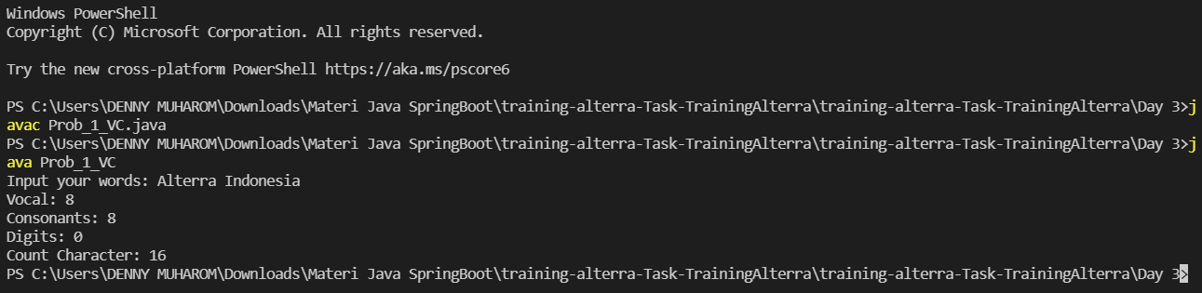

Problem 2 -> X & O

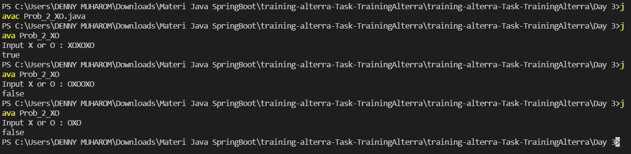

Problem 3 -> Faktor Bilangan

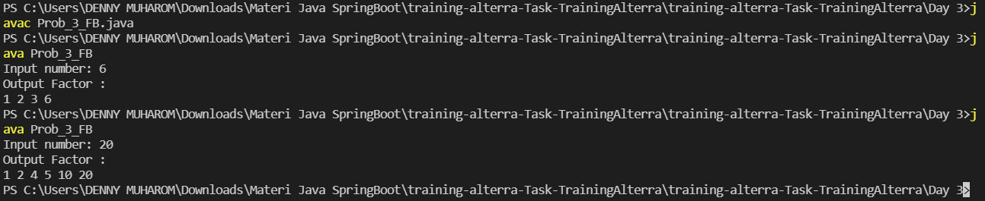

Problem 4 -> Bilangan Prima

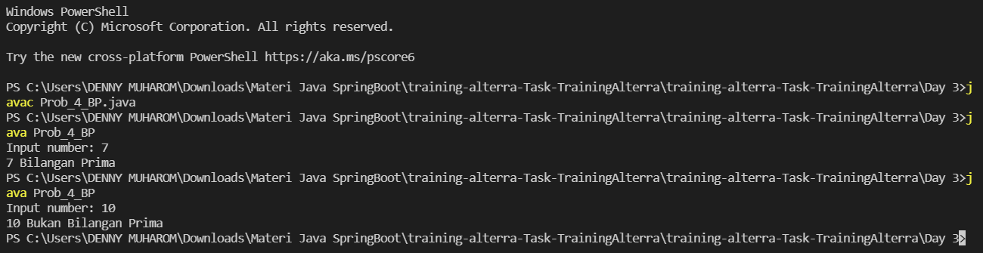

Problem 5 -> Palindrome

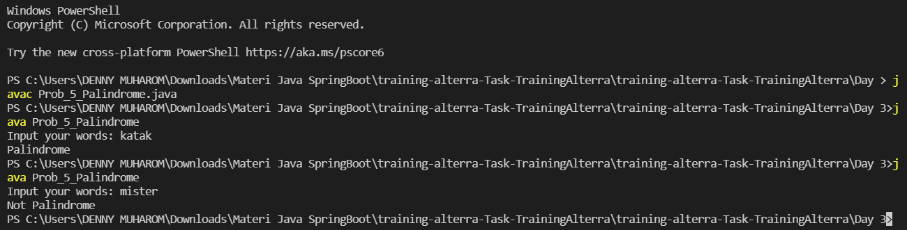

Problem 6 -> Exponentiation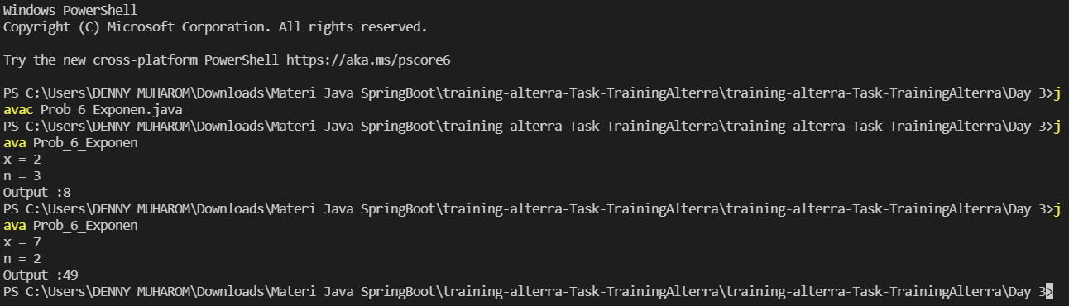

Problem 7 -> Play with Asterisk

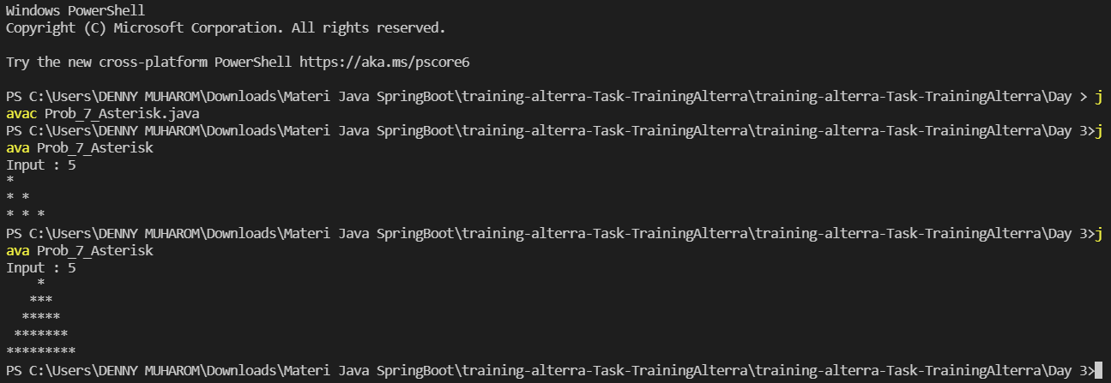

Problem 8 -> Cetak Tabel Perkalian

